VI BCA-Web Programming Laboratory

**1. Create a form having number of elements (Textboxes, Radio buttons, Checkboxes, and so on). Write JavaScript code to count the number of elements in a form.**

<html>

<head>

<title> Count form elements </title>

<script type="text/javascript">

function countFormElements()

{

alert("the number of elements are :"+document.myForm.length);

}

</script>

</head>

<body bgcolor=cyan>

<h1 align=center>Counting Form Elements </h1>

<hr>

<form name="myForm" align=left>

1. Name : &nbsp&nbsp&nbsp&nbsp<input type=text/> <br><br>

2. Password: <input type="password"/><br><br>

3. Address:&nbsp&nbsp<textarea id="emailbody" cols=50 rows=10></textarea>

<br><br>

4. Sex:<input type=radio name=gender/>Male

<input type=radio name=gender/>Female<br><br>

5. Newsletter <input type=checkbox checked="checked"/><br><br>

<input type=button value="Send Message" onclick="countFormElements()" />

</form>

</body>

</html>

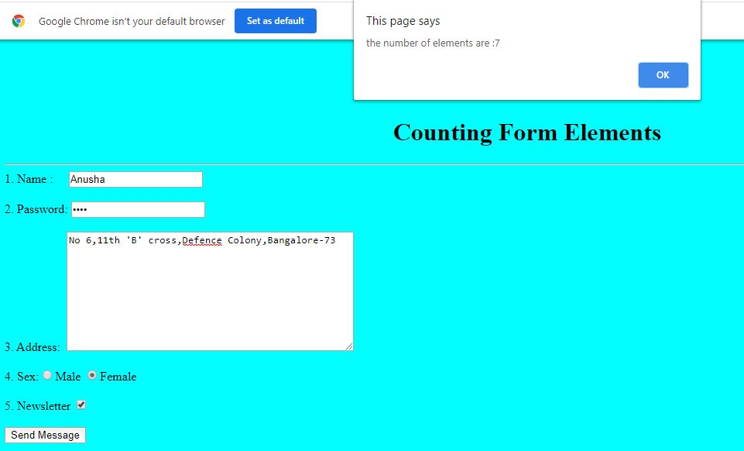

**2. Create a HTML form that has number of Textboxes. When the form runs in the Browser fill the textboxes with data. Write JavaScript code that verifies that all textboxes has been filled. If a textboxes has been left empty, popup an alert indicating which textbox has been left empty.**

<html>

<head>

<title> Validate Text Boxes </title>

<script type="text/javascript">

function validate()

{

var myArray=new Array();

for(var i=0;i<document.myForm.length;i++)

{

if(document.myForm.elements[i].value.length==0)

{

myArray.push(document.myForm.elements[i].name);

}

}

if(myArray.length!=0)

{

alert("the following text boxes are empty:\n"+myArray);

}

}

</script>

</head>

<body bgcolor=cyan><br><br><br><br><br><br><br><br>

<h1 align=center> Text Box Validation </h1>

<hr>

<form name="myForm" onSubmit="validate()">

Name : <input type=text name="name" /> <br> <br>

Class : &nbsp<input type=text name="class"/> <br> <br>

Age :&nbsp&nbsp&nbsp <input type=text name="Age"/><br> <br>

<input type="submit" value="Send Message"/>

</form>

</body>

</html>

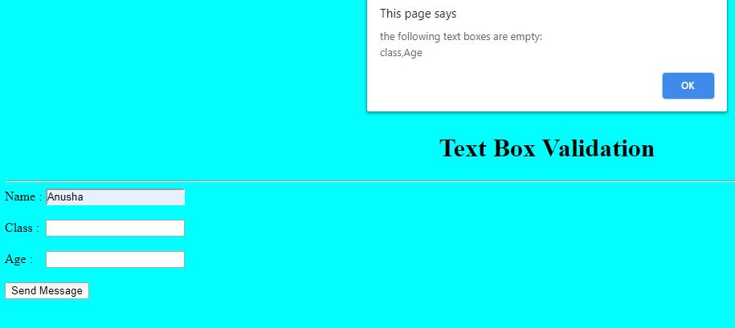

**3. Develop a HTML Form, which accepts any Mathematical expression. Write JavaScript code to evaluate the expression and displays the result.**

<html>

<head>

<title>Mathematical Expression</title>

<script type="text/javascript">

function calc()

{

document.Sample.answer.value = eval(document.Sample.calculate.value)

//eval() is a builtin function to calculate the maths expression

}

</script>

</head>

<!-- Here 'Sample' is the form's name and 'calculate' is the element's name. Both names should be distinct. -->

<body bgcolor=cyan>

<h1 align=center>Mathematical Expression</h1>

<form name="Sample">

Enter the Expression:<input type="text" size="20" name="calculate"/><br><br>&nbsp&nbsp&nbsp&nbsp&nbsp&nbsp&nbsp

<input type="button" name="Btn1" value="Calculate" onclick="calc()"/><br><br>

Result:<input type="text" size="20" name="answer"/><br><br>

<input type="reset" name="Btn2" value="Reset"/>

</form>

</body>

</html>

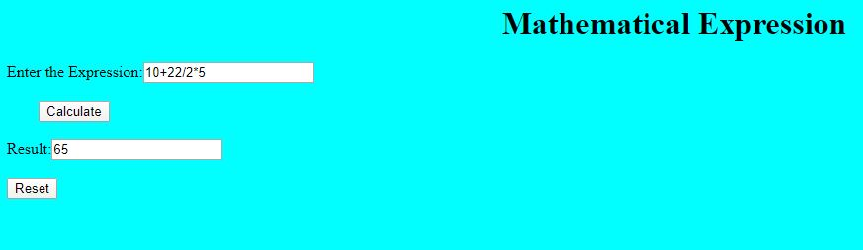

**4. Create a page with dynamic effects. Write the code to include layers and basic animation.**

<html>

<head>

<title> Basic Animation </title>

<style>

#layer1 {position:absolute; top:50px;left:50px;}

#layer2 {position:absolute;top:100px; left:250px;}

#layer3 {position:absolute; top:200px;left:450px;}

</style>

<script type="text/javascript">

function moveImage(layer)

{

var top=window.prompt("Enter Top value");

var left=window.prompt("Enter Left Value");

document.getElementById(layer).style.top=top+'px';

document.getElementById(layer).style.left=left+'px';

}

</script>

<head>

<body bgcolor=cyan>

<div id="layer1"><img src="C:\Users\admin\Desktop/ball.jpg" onclick="moveImage('layer1')" alt="MyImage"></div>

<div id="layer2"><img src="C:\Users\admin\Desktop/ball.jpg" onclick="moveImage('layer2')" alt="MyImage"></div>

<div id="layer3"><img src="C:\Users\admin\Desktop/ball.jpg" onclick="moveImage('layer3')" alt="MyImage"></div>

</body>

</html>



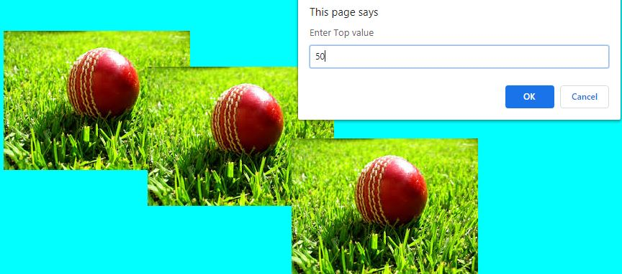

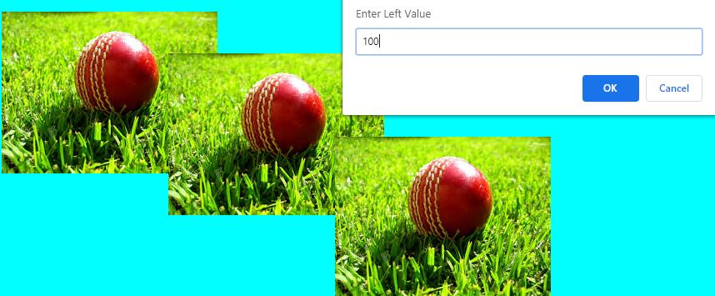

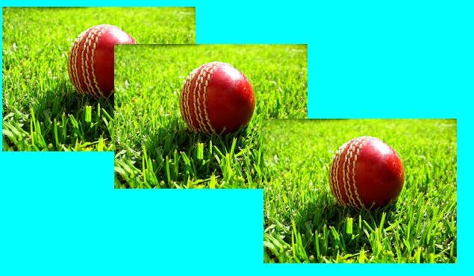

**5.Write a JavaScript code to find the sum of N natural Numbers. (Use user-defined function)**

<html>

<head>

<title> Sum of Natural Numbers </title>

<script type="text/javascript">

function sum()

{

var num=window.prompt("Enter the value of N");

var n =parseInt(num);

var sum=(n*(n+1))/2;

window.alert("Sum of First" + n + "Natural numbers is:"+sum);

}

</script>

</head>

<body bgcolor=cyan>

<h2 align=left> Finding Sum of N Natural Numbers </h2>

<hr>

<form align=center>

<input type="button" value="Click Here " onclick="sum()"/>

</form>

</body>

</html>

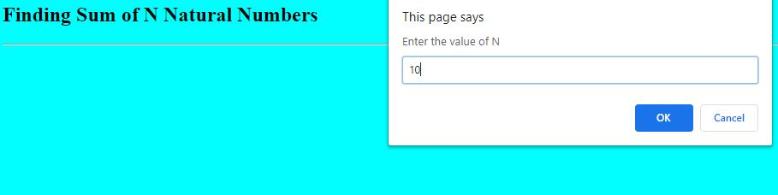

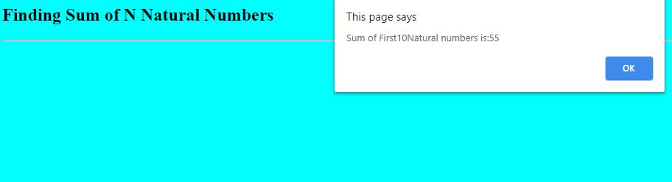

**6. Write a JavaScript code block using arrays and generate the current date in words, this should include the day, month and year.**

<html>

<head>

<title>Current Date</title>

<script type="text/javascript">

function display()

{

var d_names = new Array("Sunday", "Monday", "Tuesday", "Wednesday", "Thursday", "Friday", "Saturday");

var m_names = new Array("January", "February", "March", "April", "May", "June", "July", "August", "September", "October", "Novemeber", "Decemeber");

var d=new Date();

var curr_day= d.getDay(); var curr_date= d.getDate(); var sup= "";

if(curr_date == 1 || curr_date == 21 || curr_date == 31)

{

sup = "st";

}

else if (curr_date == 2 || curr_date == 22)

{

sup = "nd";

}

else if(curr_date == 3 || curr_date == 23)

{

sup = "rd";

}

else

{

sup = "th";

}

var curr_month = d.getMonth(); var curr_year = d.getFullYear();

document.write("<h1><center>" + d_names[curr_day] + " " + curr_date + "<SUP>" + sup + "</SUP>" + m_names[curr_month] + " " + curr_year + "</center></h1>");

}

</script>

</head>

<body bgcolor="cyan">

<form>

<input type=button value="Click Here" onclick="display()" />

</form>

</body>

</html>

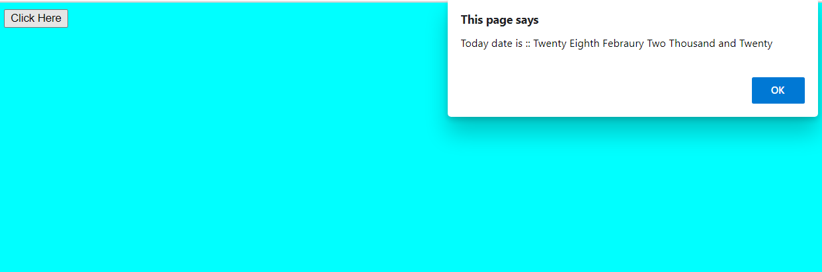

**7. Create a form for Student information. Write JavaScript code to find Total, Average, Result and Grade.**

<html>

<head>

<title> Student Marks Report </title>

<script type="text/javascript">

function showResult()

{

var name = document.getElementById("name").value;

var cls = document.getElementById("class").value;

var marks1 = parseInt(document.getElementById("sub1").value);

var marks2 = parseInt(document.getElementById("sub2").value);

var marks3 = parseInt(document.getElementById("sub3").value);

var total = marks1 + marks2 + marks3;

var avg = total / 3;

var grade, result;

if (avg >= 60)

{

grade = "A";

result = "First Class";

}

else if (avg < 60 && avg >= 50)

{

grade = "B";

result = "Second Class";

}

else if (avg < 50 && avg >= 40)

{

grade = "C";

result = "Third Class";

}

else

{

grade = "D";

result = "Fail";

}

document.write("<body bgcolor=pink>");

document.write("<h2> Student Marks Report </h2>");

document.write("<hr>");

document.write("<b> Name :" + name + "</b> <br><br>");

document.write("<b> Class :" + cls + "</b> <br><br>");

document.write("<b> Total Marks :" + total + "</b> <br><br>");

document.write("<b> Average :" + avg + "</b> <br><br>");

document.write("<b> Grade :" + grade + "</b> <br><br>");

document.write("<b> Result :" + result + "</b> <br><br>");

document.write("</body>");

}

</script>

</head>

<body bgcolor=cyan>

<form>

<table border="5">

<tr>

<th> Student Data Form </th>

</tr>

<tr>

<td> Student Name </td>

<td><input type=text id=name name="sname"></td>

</tr>

<tr>

<td> Class </td>

<td><input type=text id=class name="class"></td>

</tr>

<tr>

<td> Subject1 Marks </td>

<td><input type=text id=sub1 name="sub1"></td>

</tr>

<tr>

<td> Subject2 Marks </td>

<td><input type=text id=sub2 name="sub2"></td>

</tr>

<tr>

<td> Subject3 Marks </td>

<td><input type=text id=sub3 name="sub3"></td>

</tr>

</table> <br> <br>

<input type=button value="ShowResult" onclick="showResult()">

</form>

</body>

</html>

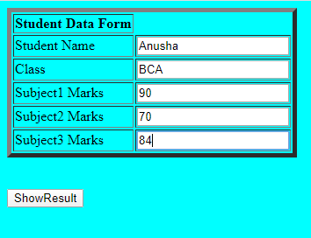

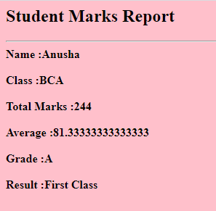

**8.Create a form for Employee information. Write JavaScript code to find DA, HRA, PF, TAX, Gross pay, Deduction and Net pay.**

<html>

<head>

<title> Employee Salary Report </title>

<script type="text/javascript">

function showSalary()

{

var name=document.getElementById("empname").value;

var empno=document.getElementById("empno").value;

var basic = parseInt(document.getElementById("basic").value);

// hra is 40% of basic

var hra=basic*0.4;

// da is 60% of basic

var da=basic*0.6

gross=basic+hra+da;

// pf is 13% of gross

var pf=gross*0.13;

// tax is 20%of gross

var tax=0.2*gross;

var deductions=pf+tax;

var netsalary=gross-deductions;

document.write("<body bgcolor=pink>");

document.writeln("<table border='5'>");

document.writeln("<tr><th colspan=2> Employee Salary Report </th> </tr>");

document.writeln("<tr><td> Employee Name:</td> <td>"+name+"</td></tr>");

document.writeln("<tr><td> Emp No : </td> <td>"+empno+"</td></tr>");

document.writeln("<tr><td> Basic Salary :</td> <td>"+basic+"</td></tr>");

document.writeln("<tr><td> HRA (40 % of basic) </td> <td>"+hra+"</td></tr>");

document.writeln("<tr><td> DA (60 % of basic</td> <td>"+da+"</td></tr>");

document.writeln("<tr><td> Gross salary : </td> <td>"+gross+"</td></tr>");

document.writeln("<tr><td> PF ( 13% of the basic )</td> <td>"+pf+"</td></tr>");

document.writeln("<tr><td> Tax (20% of the gross) : </td> <td>"+tax+"</td></tr>");

document.writeln("<tr><td>Deductions (PF + Tax) </td> <td>"+deductions+"</td></tr>");

document.writeln("<tr><td>Net Salary (Gross - Deductions) : </td> <td>"+netsalary+"</td></tr>");

document.writeln("</table>");

document.write("</body>");

}

</script>

<body bgcolor="cyan")

<form>

<table border="5">

<tr> <th colspan=2> Employee Salary Form </th></tr>

<tr>

<td> Employee Name :</td>

<td> <input type="text" id="empname"/></td>

</tr>

<tr>

<td> Employee Number </td>

<td> <Input Type ="text" id="empno"/> </td>

</tr>

<tr>

<td> Basic Pay </td>

<td> <input type=text id=basic /></td>

</tr>

</table>

<br>

<input type=button value="Show Salary" onclick="showSalary()">

</form>

</html>

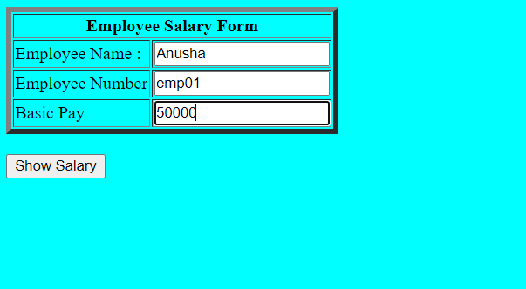

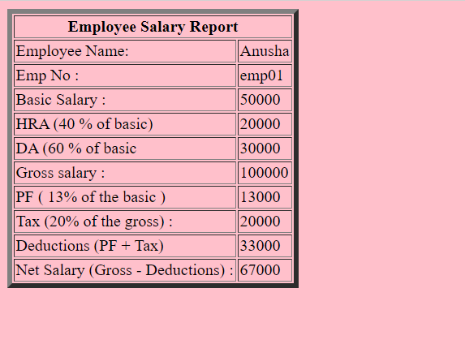

**9.Create a form consists of a two Multiple choice lists and one single choice list,**

**The first multiple choice list, displays the Major dishes available.**

**The second multiple choice list, displays the Starters available.**

**The single choice list, displays the Soft drinks available.**

**The selected items from all the lists should be captured and displayed in a Text Area along with their respective costs. On clicking the ‘Total Cost’ button, the total cost of all the selected items is calculated and displayed at the end in the Text Area. A ‘Clear’ button is provided to clear the Text Area.**

<html>

<head>

<title> MacDonalds Restaurant </title>

<script text="text/javascript">

function findCost()

{

var major=document.getElementById("major");

var starters = document.getElementById("starters");

var soft = document.getElementById("soft");

var selectedItems="Item\t\t\t Price \n..................\n";

var totcost=0;

for(var i=0;i<major.options.length; i++)

{

var option = major.options[i];

if(option.selected==true)

{

var price = parseInt(option.value);

totcost=totcost + price;

selectedItems=selectedItems+option.text+"\t\t"+price+"\n";

}

}

for(var i=0; i<starters.options.length;i++)

{

var option = starters.options[i];

if(option.selected==true)

{

var price = parseInt(option.value);

totcost=totcost + price;

selectedItems=selectedItems+option.text+"\t\t"+price+"\n";

}

}

var softdrinkIndex=soft.selectedIndex;

if(softdrinkIndex!=-1)

{

var selectedSoftdrink=soft.options[soft.selectedIndex].text;

var price = parseInt(soft.options[soft.selectedIndex].value);

totcost=totcost+price;

selectedItems=selectedItems+selectedSoftdrink+"\t\t\t"+price+"\n.......\n";

}

selectedItems=selectedItems+"Total cost \t\t" + totcost+"\n...................\n";

document.getElementById("ordereditems").value=selectedItems;

}

</script>

</head>

<body bgcolor=cyan text=blue>

<h1 align=center> Mc Donald's Restaurant </h1>

<hr>

<form name="Menu Form">

<table border=10 align=center>

<tr>

<th colspan=2 align=center>

<h2> Items Menu</h2> </th>

</tr>

<tr>

<td> Major Dishes : </td>

<td> <select id=major size=3 multiple="multiple">

<option value=100> Vegetable Pulav </option>

<option value=150> Hyderabadi Biriyani </option>

<option value=50> Roti with Curry </option>

</td>

</tr>

<tr>

<td> Starters </td>

<td> <select id="starters" size=3 multiple="multiple">

<option value=80> Gobi Manchurian </option>

<option value=40> Veg Soup </option>

<option value=30> Masala Papad </option>

</td>

</tr>

<tr>

<td> Soft Drinks </td>

<td> <select id="soft" size=1>

<option value=20> Pepsi </option>

<option value=30> Coke </option>

<option value=10>LimeSoda</option>

</select>

</td>

</tr>

<tr>

<td colspan=2 align=center>

<textarea id="ordereditems" rows=10 cols=40></textarea>

</td>

</tr>

<tr>

<td> <input type=button value="Find Total Cost" onClick="findCost()"/></td>

<td> <input type=reset value=clear /></td>

</tr>

</table>

</form>

</html>

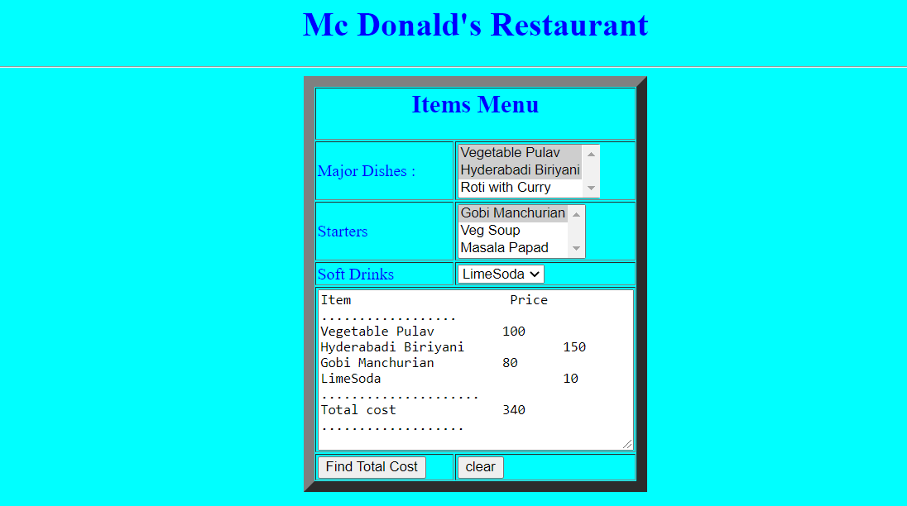

**10.Create a web page using two image files, which switch between one another as the mouse pointer moves over the images. Use the onMouseOver and onMouseOut event handlers.**

<html>

<head>

<title> Mouse Over and Mouse Out </title>

<style type="text/css">

#image1

{

position:absolute; top:100px, left:100px , border:thin, visibility:visible;

}

#image2

{

position:absolute; top:50px, left:50px , border:thin, visibility:hidden;

}

</style>

<script type="text/javascript">

function changeImage()

{

var imageOne=document.getElementById("image1").style;

var imageTwo=document.getElementById("image2").style;

if(imageOne.visibility=="visible")

{

imageOne.visibility="hidden";

imageTwo.visibility="visible";

}

else

{

imageOne.visibility="visible";

imageTwo.visibility="hidden";

}

}

</script>

</head>

<body bgcolor="cyan" text=blue>

<h1 align = center> Mouse Events </h1>

<hr>

<form >

<img src="zoozoo.jpg" id="image1" onMouseOver="changeImage()" onMouseOut="changeImage()"></img>

<img src="zoozoo2.jpg" id="image2" onMouseOver="changeImage()" onMouseOut="changeImage()"></img>

</form>

</body>

</html>

**Mouse move in**

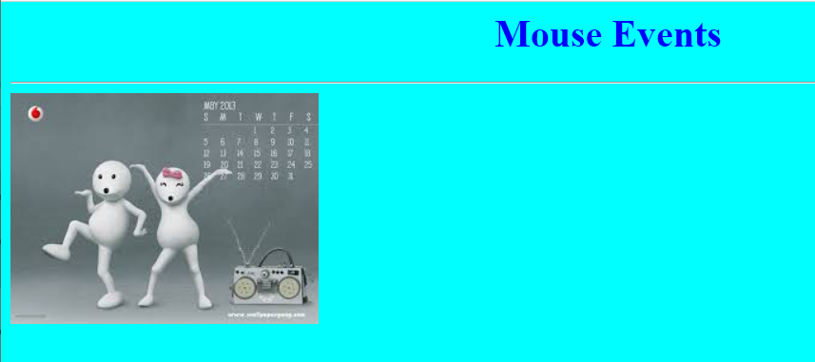

**Mouse move out**

